**Multiplayer Network Game Proposal**

**Student Names** : Muhammad Farhan & Joviin Charles

**Student ID** : 1234567 & 1298765

**Class** : DGDD/FT/2A/01 & 03

1. **Game Title**

Qubes

**2.0 Game Mechanics**

Give as much precise details as to how the game actually operates i.e. what are its rules and how the player interacts with them. Minimally it should encompass:

Objective

Survivors: Run, hide and collaborate with other team mates as try to repair generator scattered around the level to activate the game and escape with your life

Killer: Hunt down and kill the survivor as you try to stop them from escaping from your purgatory

Game theme

Survival Horror

Control and perspective

Survivor: Third person view, able to interact own set of specific items(wooden plank to block path and generator)

Killer First person view, have a weapon in which he can use to damage and knock survivor out. Can grab down player and bring them to a magic circle to “Exorcise” them

Both are controllable via controller and keyboard

Platform

PC

**2.0 Level Construction**

Main Component

Squared shape map which contain:

Nul

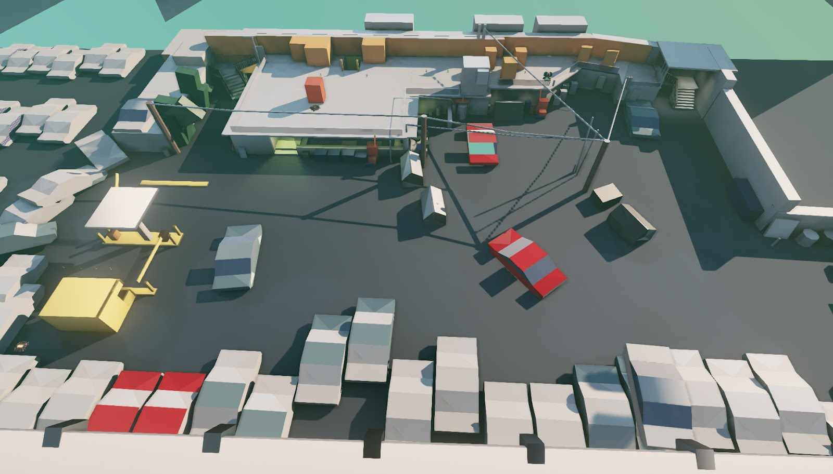

World Blocking in Unity

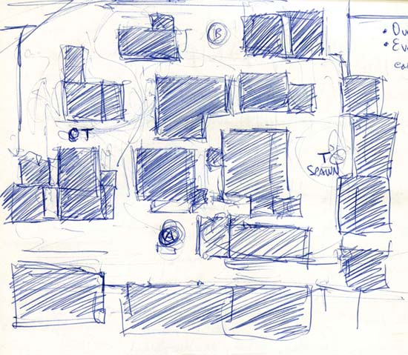 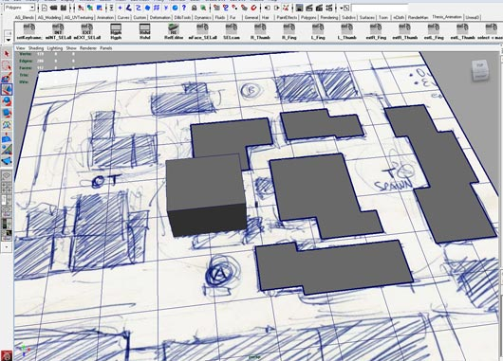

Hand Sketch Concept Map with World Blocking in 3DS Max

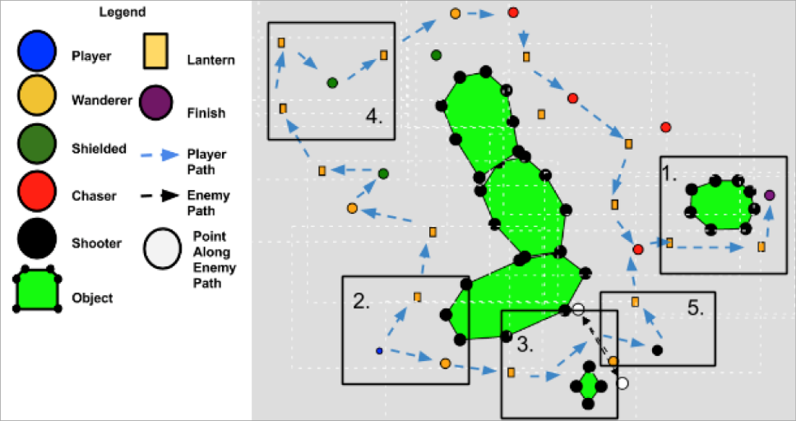

Map Legend with Description

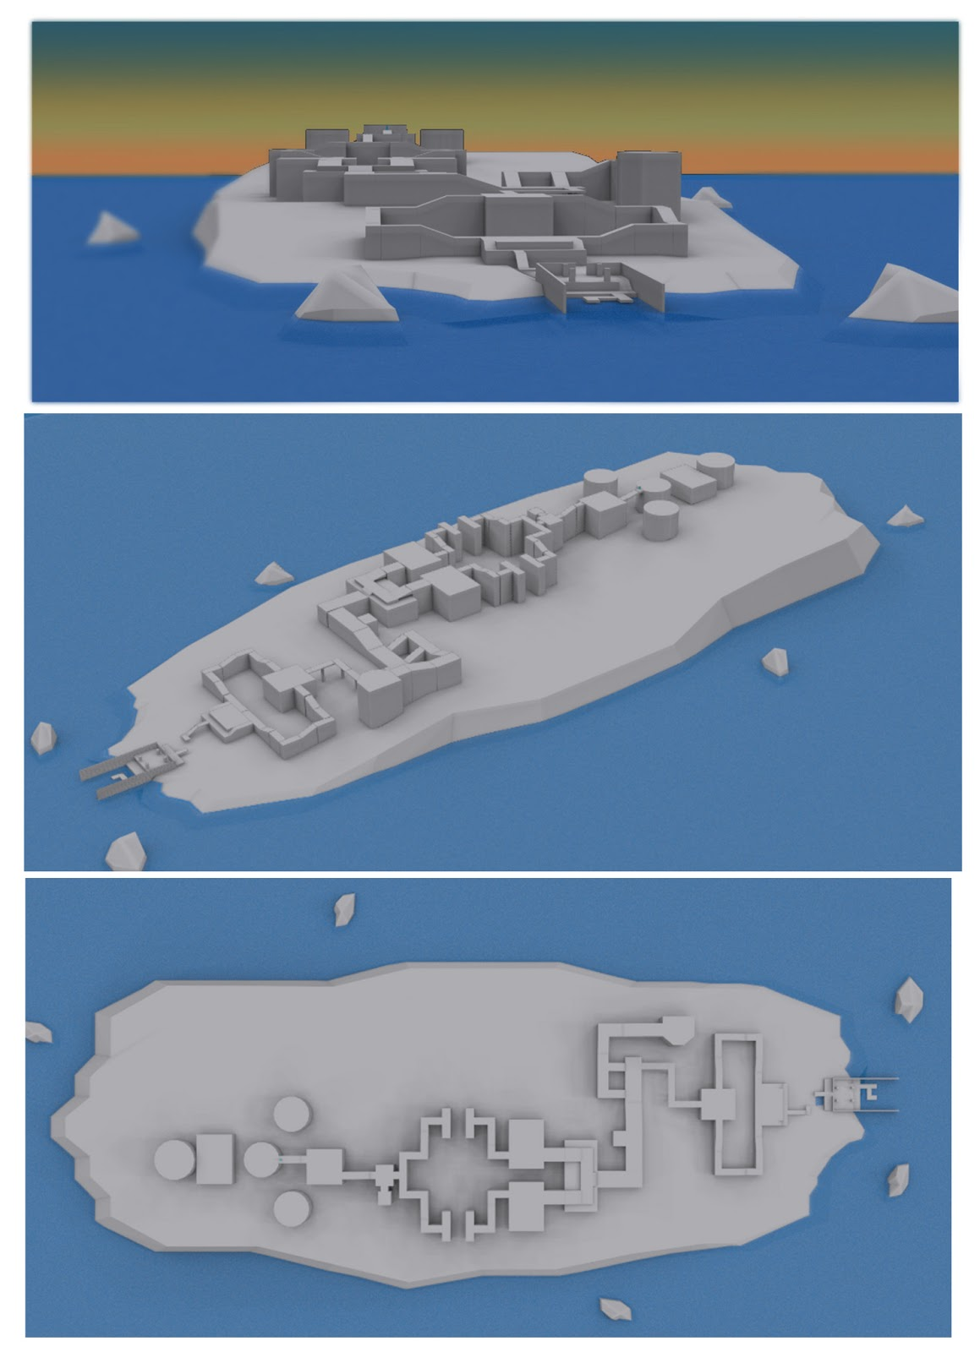

Snapshot Views of Level at Various Angles